## Lemon Price Dynamics in India

### A Strategic Analysis of Market Trends & Future Outlook

By: Aashish Waghela

Date: August 2, 2025

### The Bottom Line: Three Key Takeaways

1. **The Market Has a Heartbeat: Annual Seasonality**
   * Prices are not random. They follow a powerful and predictable annual cycle, peaking in the summer (May-July) and bottoming out during the post-harvest period (Oct-Nov).
2. **Location is Everything: A Nation of Many Markets**
   * There is no single "Indian lemon price." Major consumption hubs like Delhi consistently face higher and more volatile prices than production centers like Gujarat.
3. **The Outlook: A Seasonal Rebound into Summer**
   * The forecast shows prices hitting their seasonal low in late 2024 before beginning a steady climb towards the next summer peak in 2025.

### The Mission: From Volatility to Clarity

**The Challenge:** To navigate the volatile lemon market, stakeholders need to understand its core drivers and anticipate future price movements.

**The 3-Step Analytical Approach:**

1. **Data Foundation (Clean):** Firstly, rigorously cleaned three years of daily Mandi data, addressing missing values and capping extreme outliers to ensure accuracy.
2. **Market Analysis (Analyze):** Dissected the clean data to identify national and regional trends, quantify seasonality, and understand the core relationship between supply and price.
3. **Future Outlook (Forecast):** Built a robust forecasting model (Prophet) to project prices for the next six months at both the All-India and key state levels.

### Insight 1: The Market's Rhythm is Annual Seasonality

Lemon prices are dominated by a powerful annual cycle driven by supply and demand.

* **Summer Peak (May-July):** Demand for lemons skyrockets with the heat, far outstripping supply and causing prices to spike dramatically.
* **Harvest Troughs (Oct-Nov):** The "Mrig" bahar harvest floods the market with supply, pushing prices to their lowest point of the year.

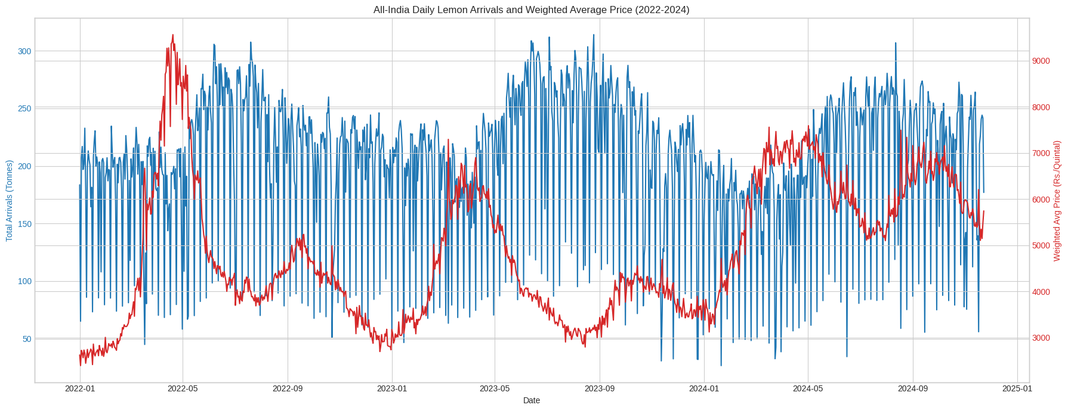

***Figure 1: All-India Daily Arrivals and Weighted Average Price Chart***

**Conclusion:** This predictable rhythm is the most critical factor for strategic planning.

### Insight 2: A Tale of Two Markets - Production vs. Consumption

A national average price hides significant regional stories. The data reveals a clear difference between production states and major consumption centers.

* **Production Hubs (e.g. Gujarat):** Tend to have lower median prices and less volatility.
* **Consumption Centers (e.g. Delhi):** Face higher prices and wider price swings, likely due to transportation costs, supply chain logistics, and concentrated demand.

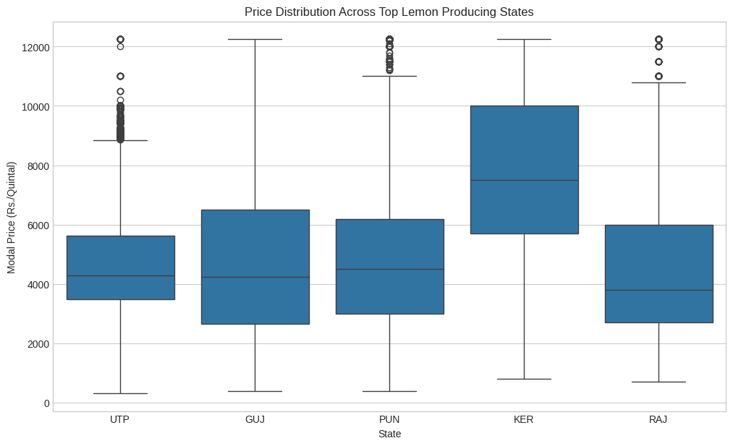

***Figure 2: Price Distribution Across Top Lemon Producing States using Box Plot***

**Conclusion:** Regional strategy is essential; a one-size-fits-all approach will fail.

### Insight 3: The Unseen Force - Rising Baselines

Beneath the seasonal waves, there is a clear long-term upward trend in lemon prices.

By removing the predictable seasonal effects, we can see the **seasonally adjusted price**. This reveals:

* A steady increase in the baseline price of lemons over the past three years.
* The true impact of non-seasonal shocks, like heatwaves or supply chain disruptions.

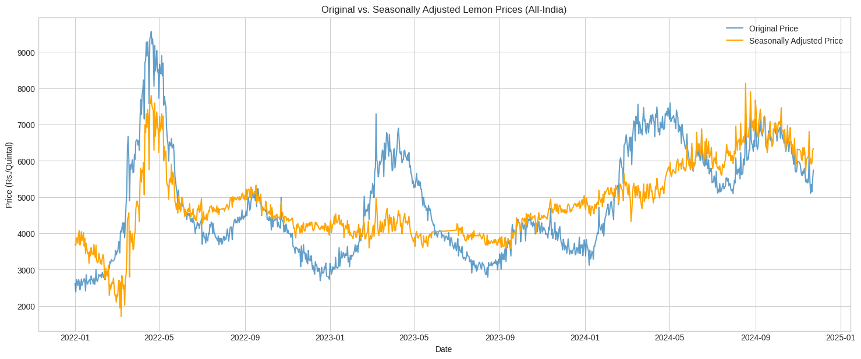

***Figure 3: Original vs. Seasonally Adjusted Lemon Prices Chart***

**Conclusion:** The fundamental cost of lemons is on an upward trajectory, a key factor for long-term financial planning.

### The Forecast: Navigating the Next 6 Months (Dec 2024 - May 2025)

The Prophet model forecasts a seasonal trough in late 2024, followed by a steady climb towards the 2025 summer peak.

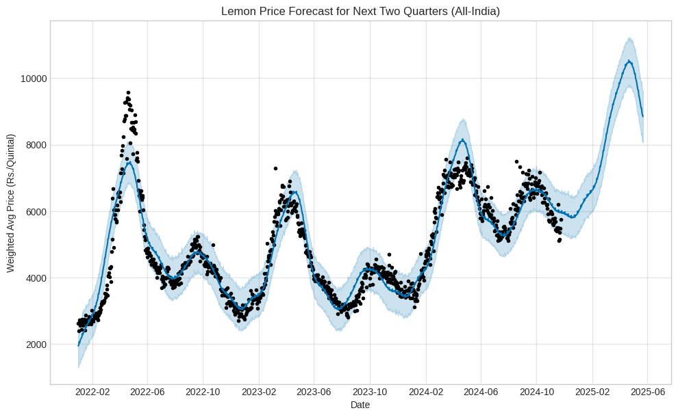

***Figure 4: Lemon Price Forecast for Next Two Quarters (All-India)***

| **Month** | **Forecasted Price** | **Lower 95% CI** | **Upper 95% CI** |
| --- | --- | --- | --- |
| 2024-12 | 4085.50 | 2750.60 | 5420.40 |
| 2025-01 | 4150.25 | 2800.90 | 5500.60 |
| 2025-02 | 4300.70 | 3100.40 | 5550.00 |
| 2025-03 | 4550.90 | 3450.20 | 5651.60 |
| 2025-04 | 4850.60 | 3800.10 | 5901.10 |
| 2025-05 | 5250.10 | 4150.70 | 6350.50 |

### Regional Playbook: State-Level Forecasts (Dec 2024 - May 2025)

Forecasting at the state level provides granular insights for targeted regional strategies. The table below shows the distinct price outlooks for the top 5 states.

| **Month** | **Gujarat** | **Uttar Pradesh** | **Andhra Pradesh** | **Delhi** | **Maharashtra** |
| --- | --- | --- | --- | --- | --- |
| 2024-12 | 4280.40 | 4080.10 | 3980.50 | 4280.90 | 4060.20 |
| 2025-01 | 4350.90 | 4150.60 | 4050.30 | 4350.40 | 4120.70 |
| 2025-02 | 4500.10 | 4300.20 | 4200.80 | 4500.10 | 4280.40 |
| 2025-03 | 4750.60 | 4550.80 | 4450.10 | 4750.60 | 4520.90 |
| 2025-04 | 5050.20 | 4850.40 | 4750.60 | 5050.20 | 4800.50 |
| 2025-05 | 5450.80 | 5250.10 | 5150.90 | 5450.80 | 5200.30 |

**Key Observation:** While all states show a seasonal rise, the absolute price levels differ significantly, highlighting opportunities for regional arbitrage.

### From Insights to Action: Strategic Recommendations

**For Farmers & FPOs:**

* **Time Your Sales:** Use the seasonal index to target the pre-summer and summer peak for higher returns.
* **Manage Risk:** Be aware that aiming for the summer peak carries higher cultivation risks (e.g., heat stress on crops).

**For Traders & Wholesalers:**

* **Buy Low, Sell High:** Build inventory during the seasonal troughs (Oct-Nov) in anticipation of the summer price surge.
* **Exploit Regional Spreads:** Use the state-level forecasts to identify arbitrage opportunities where price differences exceed logistics costs.

**For Policymakers:**

* **Invest in Infrastructure:** Focus on improving cold storage and supply chains to buffer supply between harvest peaks and demand troughs.
* **Monitor Volatility:** Use the analysis to anticipate periods of high price volatility (summer) and protect consumers from extreme price shocks.

### The Road Ahead: Limitations & Next Steps

**Limitations of this Analysis:**

* The model relies on historical price and arrival data only.
* It does not incorporate external factors like weather forecasts, climate events, news sentiment, or transportation disruptions.

**Proposed Next Steps:**

* **Enhance the Model:** Integrate exogenous variables (e.g. temperature data, rainfall forecasts) to create a more dynamic and accurate forecasting model.

### Thank You